Software Requirements Specification (SRS Document)

For

**E-commerce for Artisans**

Submitted as a part of the course curriculum for

**Bachelor of Technology**

in

**Computer Science**



**Submitted by**

Nikhil Garg(2100290120113)

Prakhar Sharma(2100290120123)

Navneet Saini(2100290120111)

Diwakar Mittal(2100290120075)

**Under the Supervision of**

Dr. Harsh Khatter

Associate Professor

**KIET Group of Institutions, Ghaziabad**

**Department of Computer Science**

**Dr. A.P.J. Abdul Kalam Technical University**

**2022-2023**

**TABLE OF CONTENTS**

|  |  |
| --- | --- |
|  | Page No. |
| TITLE PAGE .................................................................................................................... | 1 |
|  |  |
| 1. INTRODUCTION | 7-13 |
| 1.1.          Introduction ……………………................................................... | 7 |
| 1.2.          Purpose………………………………………………………….. | 9 |
| 1.3.          Scope……………………………………………………………. | 11 |
| 1.4 List of Abbreviation……………………………………………..  1.5 References……………………………………………………….    2. OVERALL DESCRIPTION    2.1 Product Perspective……………………………………………….  2.2 Product Features…………………………………………………...  2.3 User Classes And Characteristics………………………………….  2.4 Operating Environment……………………………………………  2.5 Design And Implementation Constraints…………………………..  2.6 Assumptions And Dependencies………………………………….. | 14-17 |
| 3. SPECIFIC REQUIREMENTS | 18-23 |
| 3.1 External Interface Requirements…………………………………..  3.2 Functional Requirements…………………………………………..  3.3 Non-functional Requirements……………………………………… | 18 |
|  | 22 |
| 4. APPENDICES  4.1 Flowchart…………………………………………………………...  4.2 ER Diagram…………………………………………………………  4.3 Glossary …………………………………………………………….  4.4 Analysis Models……………………………………………………. | 24 |
|  |  |
|  |  |

**INTRODUCTION**

In the dynamic landscape of commerce, the integration of technology has become paramount, transforming the way artisans bring their craft to the world. The "E-Commerce for Artisans" project is a visionary initiative poised to revolutionize the traditional artisan marketplace, embracing the digital realm to empower skilled craftsmen and craftswomen.

This project aims to create a dedicated online platform, providing artisans with an accessible and expansive marketplace to showcase and sell their unique creations. By leveraging the capabilities of e-commerce, we seek to break down geographical constraints, allowing artisans to connect with a global audience and significantly broaden their market reach.

In addition to facilitating transactions, our initiative is committed to preserving cultural heritage, fostering sustainable practices, and nurturing a sense of community among artisans and art enthusiasts alike. The intersection of tradition and technology is at the core of this endeavor, promising not just economic empowerment for artisans but also a celebration of the rich tapestry of global craftsmanship in the digital age. Join us on this journey to redefine how the world appreciates and engages with artisanal excellence.

**PURPOSE**

The purpose for an e-commerce project for artisans should align with the mission of empowering artisans, expanding their market reach, and fostering sustainable growth. Here are some suggested objectives:

1. **Global Reach:** Enable artisans to reach a wider audience by providing a platform that transcends geographical boundaries, allowing them to showcase and sell their creations globally.

2. **Economic Empowerment:** Facilitate economic empowerment by increasing sales opportunities for artisans, thereby improving their financial sustainability and supporting their livelihoods.

3. **Digital Literacy:** Promote digital literacy among artisans, offering training and support to enhance their ability to navigate and manage their online presence effectively.

4. **Cultural Preservation:** Emphasize the preservation of cultural heritage by showcasing and promoting traditional craftsmanship, fostering an appreciation for diverse art forms on a global scale.

5. **Community Building:** Foster a sense of community among artisans and customers, creating an interactive platform that encourages collaboration, feedback, and the exchange of ideas.

6. **Sustainability:** Encourage sustainable practices by highlighting environmentally friendly and ethically produced artisanal products, aligning with the growing demand for eco-conscious consumer choices.

7. **User-Friendly Interface:** Develop an intuitive and user-friendly e-commerce platform, ensuring artisans can easily manage their online storefronts without technical barriers.

8. **Secure Transactions:** Implement robust security measures to safeguard financial transactions and customer data, building trust and confidence in the platform.

9. **Marketing and Branding Support:** Provide tools and resources for artisans to effectively market their products and build a recognizable brand, helping them stand out in the competitive e-commerce landscape.

10. **Innovation:** Encourage innovation in artisanal practices by showcasing unique and contemporary creations, fostering a space where traditional craftsmanship can evolve with modern trends.

11. **Feedback Mechanism:** Establish a feedback mechanism for artisans to receive insights from customers, facilitating continuous improvement in product quality and customer satisfaction.

12. **Accessibility:** Ensure that the e-commerce platform is accessible to artisans with varying levels of technological proficiency, promoting inclusivity and equal opportunities for all artisans.

13. **Data Analytics:** Implement data analytics tools to provide insights into customer behavior, preferences, and market trends, empowering artisans to make informed decisions about their product offerings.

14. **Collaborations and Partnerships:** Facilitate collaborations and partnerships with other organizations, both within and outside the artisan community, to broaden opportunities and create synergies.

15. **Legal and Regulatory Compliance:** Ensure compliance with relevant legal and regulatory frameworks, safeguarding the rights and interests of both artisans and customers within the e-commerce ecosystem.

**SCOPE**

The scope of an e-commerce project for artisans is vast, encompassing various aspects to create a comprehensive platform. Here's an overview of the potential scope for such a project:

1. **Artisan Onboarding:**

- Develop a user-friendly registration process for artisans to join the platform.

- Collect and verify essential information about artisans and their craft.

2. **Storefront Creation:**

- Enable artisans to create personalized online storefronts showcasing their products.

- Provide tools for uploading high-quality images, product descriptions, and pricing.

3. **Product Management:**

- Implement a system for artisans to add, edit, and remove products easily.

- Include features for categorizing products to enhance user navigation.

4. **E-commerce Functionality:**

- Integrate secure payment gateways for seamless transactions.

- Implement a shopping cart and order management system.

5. **Search and Filters:**

- Develop robust search functionality and filters to help users find specific artisan products.

- Include sorting options based on various criteria like price, popularity, or category.

6. **Community and Reviews:**

- Incorporate a community space for artisans and customers to interact.

- Implement a review and rating system to build trust and credibility.

7. **Mobile Responsiveness:**

- Ensure the platform is accessible and optimized for mobile devices.

8. **Marketing and Promotions:**

- Integrate promotional tools such as discounts, coupons, and featured product showcases.

- Implement a newsletter or notification system to keep users informed about new products or promotions.

9. **Analytics and Reporting:**

- Provide analytics tools for artisans to track the performance of their storefronts.

- Implement overall platform analytics for administrators to assess user behavior and improve the platform.

10. **Shipping and Logistics:**

- Integrate shipping options and provide tracking features.

- Offer various shipping methods and calculate shipping costs based on location.

11. **Legal and Compliance:**

- Ensure compliance with e-commerce regulations and standards.

- Implement terms of service, privacy policies, and secure data storage practices.

12. **Customer Support:**

- Provide a customer support system for inquiries, complaints, or assistance.

- Include chatbots or FAQs to address common queries.

13. **Technology Stack:**

- Choose a suitable technology stack for the platform's development, considering scalability and security.

14. **Sustainability and Social Impact:**

- Integrate features that highlight sustainable practices and the social impact of supporting artisans.

15. **Expansion and Scalability:**

- Design the platform with scalability in mind, allowing for future expansion and additional features.

By addressing these aspects, your e-commerce project for artisans can create a comprehensive and engaging platform that benefits both artisans and customers.

**LIST OF ABBREVIATIONS**

Here is a list of possible abbreviations related to e-commerce for artisans:

1. **ECFA:** E-Commerce for Artisans

2. **AMC:** Artisan Marketplace Connect

3. **AAC:** Artisan Accessible Commerce

4. **AOC:** Artisan Online Commerce

5. **AIC:** Artisan Internet Commerce

6. **AACM:** Artisan e-Commerce Marketplace

7. **AET:** Artisan E-Trade

8. **ECA:** E-Commerce Artisans

9. **ACE:** Artisan Craft Exchange

10. **AEA:** Artisan E-Commerce Alliance

11. **AICP:** Artisan Internet Commerce Platform

12. **CEA:** Craftsmen E-Commerce Association

13. **ACM:** Artisan Commerce Hub

14. **EAF:** E-Commerce Artisan Fair

15. **AEF:** Artisan E-Commerce Forum

16. **ACO:** Artisan Commerce Online

17. **AEI:** Artisan E-Commerce Initiative

18. **AEM:** Artisan E-Market

19. **ARTEC:** Artisan E-Commerce Technology

20. **AECP:** Artisan E-Commerce Portal

**REFERENCES**

1. **"E-Commerce 202X: The Essential Guide to Online Business" by Rob Thomas**

2. **"The Lean Startup: How Today's Entrepreneurs Use Continuous Innovation to Create Radically Successful Businesses" by Eric Ries**

3. **"E-Commerce Get It Right!: Essential Step by Step Guide for Selling & Marketing Products Online" by Ian Daniel**

4. **"Craft Business Power: 15 Days to a Profitable Online Craft Business" by Jason G. Miles**

5. **"The Handmade Marketplace: How to Sell Your Crafts Locally, Globally, and Online" by Kari Chapin**

6. **"Art Inc.: The Essential Guide for Building Your Career as an Artist" by Lisa Congdon**

7. **"Etsy-preneurship: Everything You Need to Know to Turn Your Handmade Hobby into a Thriving Business" by Jason Malinak**

**OVERALL DESCRIPTION**

**PRODUCT PERSPECTIVE**

Our E-commerce system is a stand-alone system which aims to focus on handmade goods, support for artisan businesses, and its role in connecting artisans with customers.

**PRODUCT FEATURES**

Our project has the following features:

* A homepage for the customer where he/she can view new products and discounts.
* The seller homepage where he/she can view their current and past shipments.
* An option of searching for products on the homepage along with filtering and sorting products according to different attributes.
* Mark products as favourites or put them in the cart and order them.
* Tracking of the delivery status.
* Payment methods used are cash on delivery, debit card, and credit card.
* A customer may post reviews of a product.
* Customers receive notifications regarding sales and discounts.
* Portal for customer support in case of any discrepancies.
* Return and replacement options for products.
* Voice recognition for searches.

**USER CLASSES AND CHARACTERISTICS**

* The user should be familiar with the Shopping Mall related terminology like Shopping cart/Checking out/Transaction etc.
* The user should be familiar with the Internet.
* Describe their characteristics and how they will use the system

**OPERATING ENVIRONMENTS**

The product will be available as a web application.

Since the product is a web-app it is available on all operating systems and platforms. Majorly, the website will run on web browsers like Google Chrome, Microsoft Edge, Safari, Mozilla Firefox. The backend of the website can be hosted on AWS/Heroku and the frontend can be hosted on Github pages or using Heroku. The database will be hosted on AWS using AWS RDS. Heroku and AWS both would be using Linux OS for the servers.

**DESIGN AND IMPLEMENTATION CONSTRAINTS**

An online store is a virtual store on the Internet where customers can browse the catalog and select products of interest. The selected items may be collected in a shopping cart. At checkout time, the items in the shopping cart will be presented as an order. At that time, more information will be needed to complete the transaction. Usually, the customer will be asked to fill or select a billing address, a shipping address, a shipping option, and payment information such as credit card number. An e-mail notification is sent to the customer as soon as the order is placed.

**ASSUMPTIONS AND DEPENDENCIES**

The assumptions are:

* The coding should be error free.
* The system should be user friendly so that it is easy to use for the users.
* The system should have more capacity and provide fast access to the database.
* The system should provide search facility and support quick transactions.
* The system is running twenty four hours a day.
* Users may access from any computer that has internet browsing capabilities and an internet connection.
* user must have their correct usernames and passwords to enter into their online accounts and do actions.

The dependencies are:

* The specific hardware and software due to which the product will be run.
* On the basis of listing requirements and specification the project will be develop and run.
* The end users (admin) should have proper understanding to the product.
* The system should have the general report store.
* The information of all users must be stored in a database that is accessible by the system.

**SPECIFIC REQUIREMENTS**

**EXTERNAL INTERFACE REQUIREMENTS**

**User Interfaces**

We plan to create a website for product. Since we plan to sell products belonging to handmade categories, we will create an easy to use interface which would have a search bar to search products on the basis of the category, price, ratings. We will have two dashboards, one for the sellers and one for the customer. On this dashboard, the customer will be able to view various deals and discounts as well as top products for each category. Each product will have its own page which will list its price, reviews, images and link to order the product. For a particular user, they will have a cart which will allow them to add or remove products. After the user has decided to order, there will be a payment gateway which will have various payment options. The website is mobile responsive, hence, can be accessed on phones and tablets. For the sellers, they will be able to view their current and past shipment on a dashboard.

**Hardware Interfaces**

Since the website will be hosted on external servers, there won’t be any hardware requirements as such on our part. The user on the other hand would need either a smartphone or a desktop/laptop to access the website or the app.

 The external server specifications would be:

* Intel Xeon processor
* Linux OS
* 4 GB RAM
* 50GB HDD storage.

The database storage required would be 5GB initially and would need to be increased further as the users increase.

**Software Interfaces**

Our product consists of a database, payment gateway, frontend and backend. There will be a connection between frontend and backend for passing information back and forth. The backend will be connected to the database for accessing information and storing transactions, product orders. Since an e-commerce website accepts payments it must be able to access, withdraw and deposit from bank accounts on providing the necessary information. Therefore, there will be a connection between our website and a payment gateway. The customer if using a smartphone must have Android version 4.4 or above and if using a desktop, he/she must have Windows 7 or above/ Ubuntu /iOS Operating System.

**Communications Interfaces**

We are using the https protocol for communicating over the internet. We must also be able to send emails and messages to the user to confirm payment and notify them about discounts as well as delivery status. We also have a customer support page where a customer can post his/her queries. We also provide an option for customers to give reviews of products. Other users can also react to those reviews.

**FUNCTIONAL REQUIREMENTS**

User Management

* Artisans should be able to register and create profiles.
* Artisans should be able to log in to their accounts securely.
* Customers should be able to register and create profiles.
* Customers should be able to log in to their accounts securely.

Product Management

* Artisans should be able to add, edit, and delete product listings.
* Each product listing should include a title, description, price, images, and category.
* Artisans should be able to manage inventory for each product.
* Products should be searchable and filterable by category, price, and other relevant attributes.
* Artisans should be able to mark products as featured or on sale.

Shopping Cart and Checkout

* Customers should be able to add products to their shopping carts.
* Customers should be able to view and edit their shopping carts.
* Customers should be able to proceed to secure checkout.
* Checkout process should include payment options, shipping address, and order summary.
* Customers should receive confirmation emails after successful checkout.

Order Management

* Artisans should be able to view and manage orders placed for their products.
* Artisans should be able to update order status (e.g., processing, shipped, delivered).
* Customers should be able to view the status of their orders.

Reviews and Ratings

* Customers should be able to leave reviews and ratings for products.
* Artisans should be able to view and respond to customer reviews.
* Ratings and reviews should be displayed publicly on product pages.

Administrative Functionality

* Administrators should be able to monitor sales and generate reports.
* Administrators should have access to site configuration settings.

**NON-FUNCTIONAL REQUIREMENTS**

**Performance** **Requirements**

There is no performance requirement in this system because the server request and response is depended on the end user internet connection.

**Safety** **Requirements**

The database may get crushed at any certain time due to virus or operating system failure. There for it is required to take the database backup so that the database is not lost. Proper UPS/ Inverter facility should be there in case of power supply failure.

**Security** **Requirements**

* System will use secured database.
* Normal users can just read information but they cannot edit or modify anything except their personal and some other information.
* System will have different types of users and every user has access constraints.

**Software** **Quality** **Attributes**

* There may be multiple admin’s creating the project, all of them will have the right to create changes to the system. But the members or other users cannot do changes.
* The project should be open source.
* The quality of the database is maintained in such a way so that it can be very user friendly to all the users of the database.
* The user be able to easily download and install the system.

**Business** **Rules**

A business rule is anything that captures and implements business policies and practices. A rule can enforce business policy, make a decision, or infer new data from existing data. This includes the rules and regulations that the system users should abide by. This includes the cost of the project and the discount offers provided. The users should avoid illegal rules and protocols. Neither admin nor members should cross the rules and regulations

**Other Requirements**

System shall handle expected and non-expected errors in ways that prevent loss in information and long downtime period

**APPENDIX**

**FLOWCHART**

**Start**

**↓**

**[Define Project Scope]**

**↓**

**[Market Research]**

**↓**

**[Identify Target Artisans]**

**↓**

**[Design User Interface]**

**↓**

**[Develop E-Commerce Platform]**

**↓**

**[Artisan Registration]**

**↓**

**[Product Listing]**

**↓**

**[Secure Payment Integration]**

**↓**

**[Order Processing]**

**↓**

**[Shipping & Delivery]**

**↓**

**[Customer Registration]**

**↓**

**[Product Browsing]**

**↓**

**[Add to Cart]**

**↓**

**[Secure Checkout]**

**↓**

**[Payment Confirmation]**

**↓**

**[Order Confirmation]**

**↓**

**[Email/SMS Notifications]**

**↓**

**[Feedback Collection]**

**↓**

**[Artisan Rating]**

**↓**

**[Analytics & Reporting]**

**↓**

**End**

**ER-DIAGRAM**

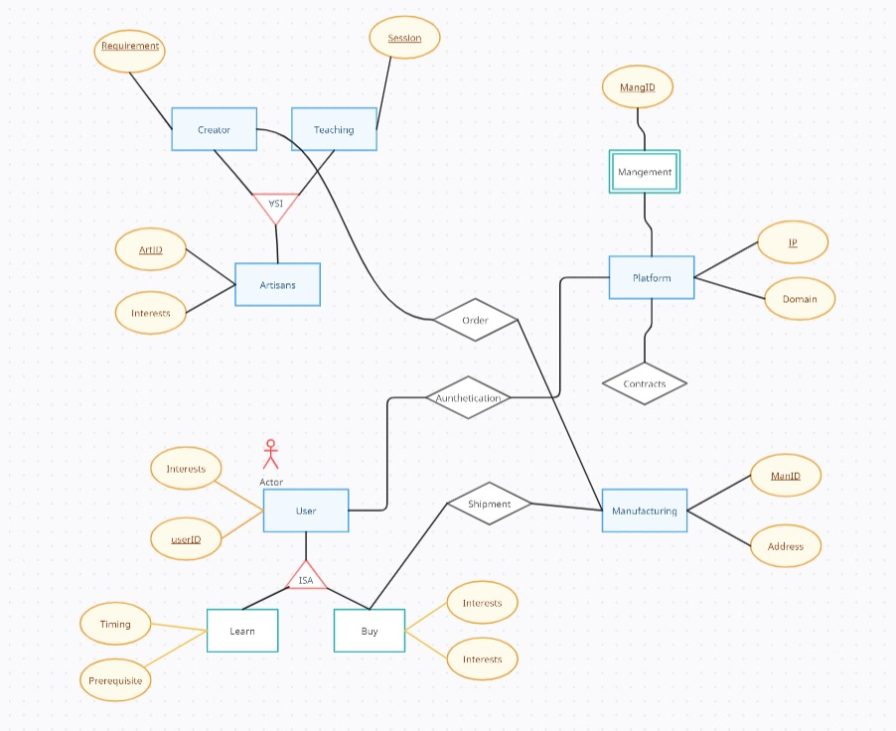

**GLOSSARY**

The following are the list of conventions and acronyms used in this document and the project as well:

User: Normally user can comment or view details of robo shop availability.

Client: Intended users for the software.

SQL: Structured Query Language; used to retrieve information from a database.

SQL Server: A server used to store data in an organized format.

Layer: Represents a section of the project.

**ANALYSIS MODELS**

User Interface Layer: The section of the assignment referring to what the user interacts with directly.

Application Logic Layer: The section of the assignment referring to the web server. This is where all computations are completed.

Data Storage Level: The section of the assignment referring to where all data is recorded.

Use Case: A broad level diagram of the project showing a basic overview.

Class diagram: It is a type of static structure diagram that describes the structure of a system by showing the system’s cases, their attributes, and the relationships between the classes.

Interface: Something used to communicate across different mediums.

Unique Key: Used to differentiate entries in a database.